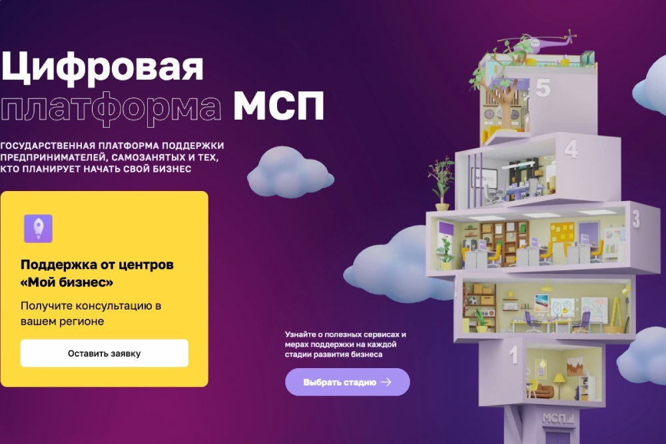

<https://мсп.рф/?utm_source=yandex_four&utm>

_medium=cpc&utm_campaign=master_mainpage&yclid=14641861670886440959